Jamaica

One of my favorite islands is Jamaica. The beaches, mountains, music and island cuisine make it a great place to visit. First of all, you must try the Jerk Chicken. Many resorts offer Jerk Shacks or Huts on the beach. Another local favorite is the Jamaica Meat Patty or Meat Pie. It is similar to an Empanada and very tasty. They offer plenty of rum drinks so be sure to try a Bob Marley or Jamaican Smile. If you are adventurous, Dunn River Falls is a must do. I also recommend Mystic Mountain. You take a ski lift to the top where you can zipline, ride the Jamaican Bobsled or enjoy the views. It is quite spectacular. The famous 7 mile beach in Negril offers some beautiful sand and amazing sunsets. There are many nice adult only and family resorts if you want to experience the *Casual* area of Jamaica. That is where I can help you decide on the best location and resort for your next trip to Jamaica!

/Users/briannaalthage/Desktop/Desktop/projects/travelSiteRep/images/storyImages/jamaica.jpg /Users/briannaalthage/Desktop/Desktop/projects/travelSiteRep/images/storyImages/jamaica.jpg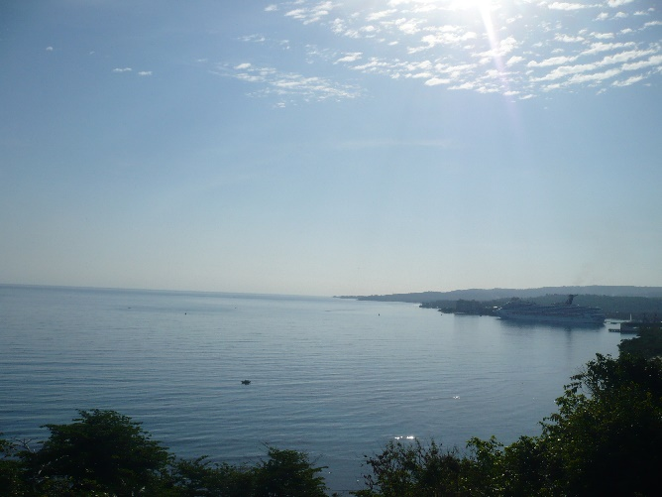 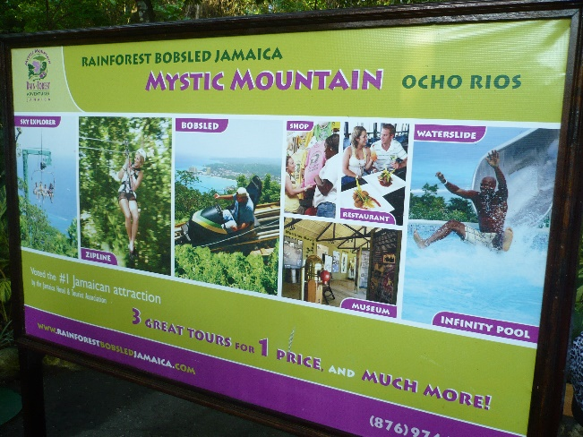

Mexico

If you are looking for plenty of activities, nice beaches and lots of options then Mexico is the place. You have the Gulf side with white sand and turquoise water. Cancun is the busy tourist area with nightlife, great beaches and high-rise resorts offering great water views. Playa del Carmen has the small-town charm if you want to shop, visit some local bars or take a ferry to Cozumel. A newer and growing area is Playa Mujeres and Costa Mujeres located around 45 minutes north of Cancun. I was very impressed on my first visit to the area. More resorts are opening soon so you can plenty of adult only or family choices while still able to enjoy some tranquility. The beaches are still quiet but long and wide but many open spaces not yet developed. You are still close enough to Cancun for excursions. Be sure to take a catamaran cruise to Isla Mujeres. Then ride a golf cart around the quaint island.

If you are like me relaxing on the beach is nice but I need things to do. There are so many exciting excursions that you can enjoy. Xplor Fuego is one of my favorites with plenty of activities such as ziplining and ATV. You can take the day tour or Fuego starts in the evening. Snorkel and scuba trips are popular since you are close to Cozumel known for its famous reef.

The Pacific side offers some great photo opportunities with its gorgeous mountains bordering the coastline. It is different with blue water and darker sand. Whale watching is popular in the winter/spring season. Cabo has Los Arcos which I recommend everyone visit at least once in their lifetime. Puerto Vallarta has its own charm with history and sits on Banderas Bay. The northern side called Riviera Nayarit has a long stretch of beach. The marina has some great resorts near the airport. Malecon is the downtown section which is fun during the day and night. If you travel farther south there is a nice little town called Huatulco. It is a newer tourist area if you truly want to relax. The town consists of several bays so you have quieter water and easy trip to the downtown square. I will help you find the perfect location and resort for your travel needs.

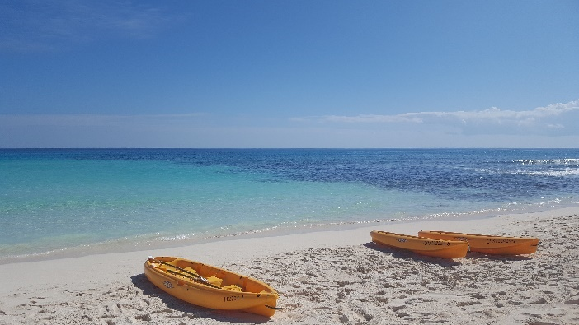 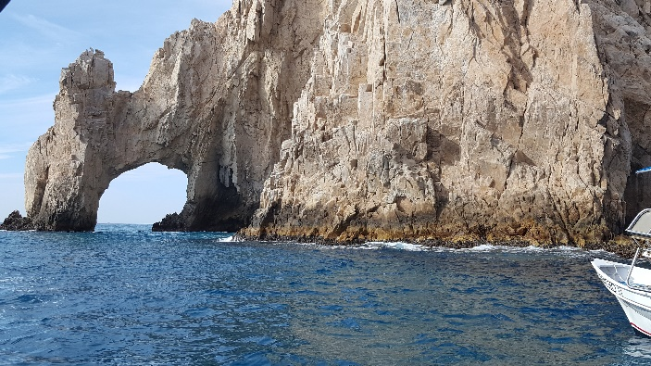

Punta Cana

If you want a destination for beautiful beaches, Punta Cana might be your place. Bavaro Beach has fine, white sand backed up by the turquoise water of the Caribbean Sea. If you head farther north, you find a variety of newer resorts where the Caribbean meets the Atlantic Ocean. I highly recommend that you take excursions when visiting the Dominican Republic. Learn about their culture and lifestyle. Anything from how to make coffee and tobacco to where they live. Of course, any water lovers will enjoy scuba or snorkeling here. You can swim with the sting rays or take a ride on a party boat. The Dominicans love baseball so feel free to strike up a conversation about the St Louis Cardinals or Albert Pujols. Again, there is a resort for any traveler so we can discuss your wants and needs to find the perfect one!

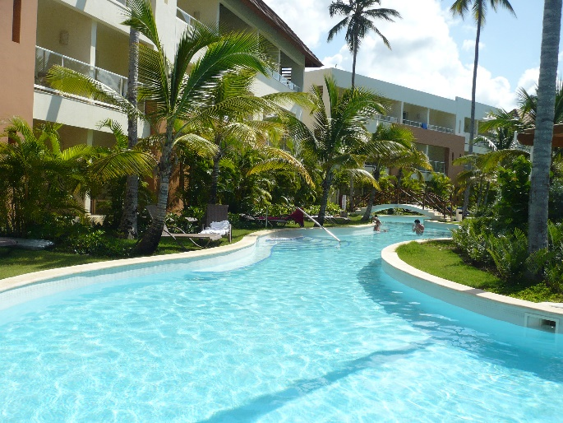 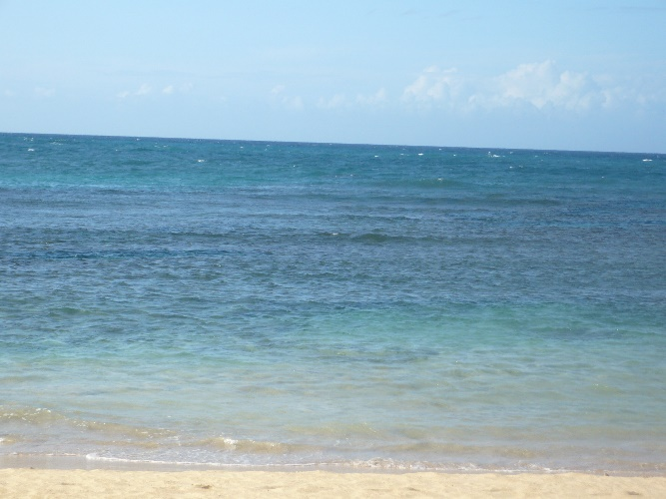

Cruising

Often, I get asked about the difference in cruising and staying at an all-inclusive resort. Simple response is …. do you want to wake up and put your feet in the sand OR wake up in a new destination? Cruising can be less or more expensive depending on a few factors. If you drive or fly to your destination, number of beverages consumed and whether you stay on the ship. Now most cruises are NOT all-inclusive. The initial booking cost may start small BUT we need to add transportation to the port, recommended pre-night hotel, gratuities and beverage packages. There are additional charges on the ship such as specialty dining, bakery/coffee shops and Wi-Fi packages.

This is not to discourage you from cruising. I personally enjoy taking a cruise every few years. It is a different experience. Some clients only prefer to cruise and that is great. The larger ships are like floating cities where it can take a week to navigate. You can drive go-kart tracks, utilize the rock-climbing walls, crash it up in the bumper cars or try the surf simulator on the newer vessels. The smaller ships can access more ports so you may visit more islands with those itineraries. Cruising is a great way to see more places without having to change hotels. I have different recommendations depending on your destination and ages of travelers. We will find the perfect cruise for your next vacation!

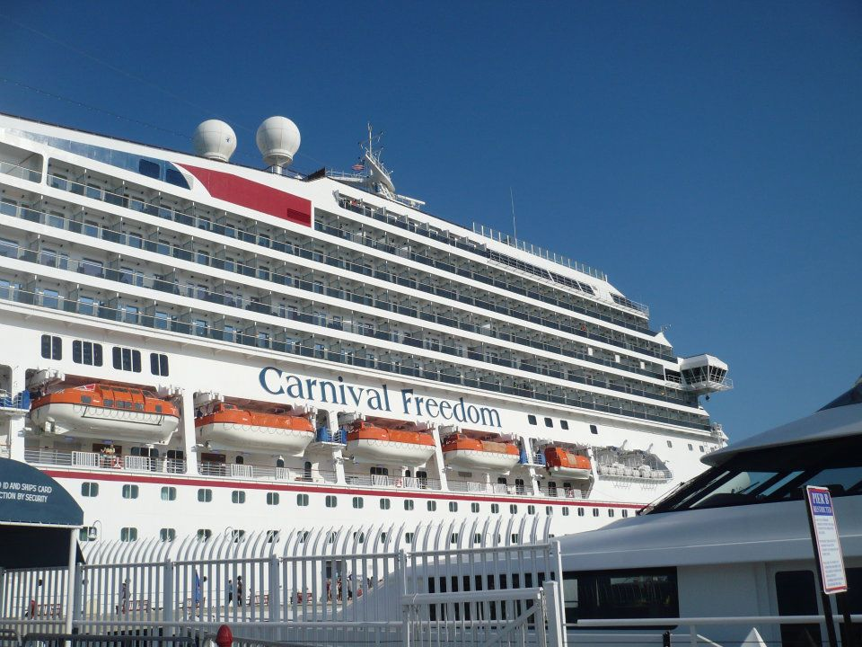 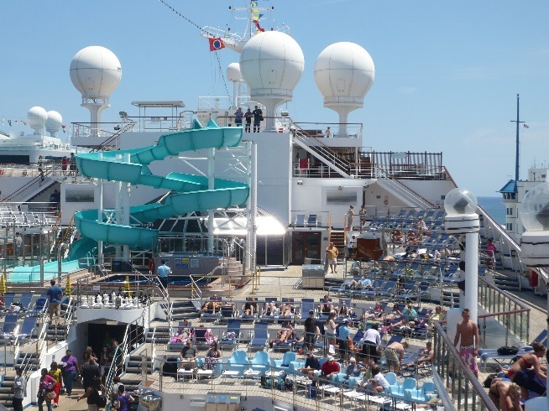

American Queen Riverboat Cruise

One of my favorite trips to date is the American Queen Riverboat Cruise. I was fortunate to be invited to a luncheon several years ago. It was then that I fell in love with this small riverboat and decided I would be back. We were able to take a Mississippi itinerary from Natchez to New Orleans one early December. This is not a trip for everyone and it is geared toward seniors older than 65. Although much younger than the average passenger, it was one of my most memorable adventures. They offered nightly, entertaining shows that you won’t find on the larger ships. The rooms were reminiscent to the Victorian era. We stopped at several fascinating cities like Baton Rouge and Vicksburg. Of course, New Orleans is an exciting and beautiful city during the Christmas holidays. Let me know if this sounds like the right trip for you!

